Our Ref: VS/AP/0016

Dear Parents/Carers,

From 1st September 2013 changes to statutory legislation regarding pupil absence came into force. The Education (Pupil Registration) (England) (Amendment) Regulations 2013 state that Head Teachers may not grant any leave of absence during term time unless there are ‘exceptional’ circumstances.

Any absence from school will disrupt your child’s learning, regardless of their academic ability. You may consider holidays as educational but your child will still miss out on invaluable teaching that their peers will receive. Children returning from a leave of absence are unprepared as their learning builds on the teaching they have missed. This will undoubtedly have an impact on your child’s assessment scores and subsequent updates. It is your child’s responsibility to catch up on all missed class work and homework during their absence.

If you wish to take your child out of the academy during term time, you will need to complete and return the attached form to your child’s Head of Year. A separate form must be completed for each child. If the leave of absence does not meet the criteria for exceptional circumstances, and you nevertheless take your child out of school, it will be recorded as unauthorised leave.

Failing to ensure regular school attendance by taking your child out of school in term time for a holiday is an offence under section 444 (1) or section 444 (1A) of the 1996 Education act. The maximum penalty for these offences is a fine of £2,500, 3 months’ imprisonment or both. Alternatively the Local Authority/School may choose to impose a Section 444A Penalty Notice in the order of a fine instead of prosecuting for the offences given above. The amount of the penalty notice is £60.00 (per parent, per child) if paid within 21 days. If paid after 21 days but within 28 days the penalty notice is doubled to £120.00 (per parent, per child). Failure to pay a Penalty Notice will result in prosecution except in limited circumstances. From 7th September 2020, all leave of absence requests must be completed on the attached form, letters will not be accepted. This should be returned to the academy at least 7 days prior to the requested absence. Leave cannot be authorised retrospectively.
In considering the decision whether to authorise the leave of absence, the following criteria will be taken into account:-
- Your child’s previous attendance record; this includes attendance in the current academic year - which should be at least 97% - as well as attendance in previous academic years.
- Reasons given for the leave of absence;
- Whether your child will miss any tests/examinations (or important preparation for their tests)
- Whether your child is making good progress.

I hope you will support us in our efforts to maintain outstanding attendance and attainment at West Lakes Academy.

Yours faithfully
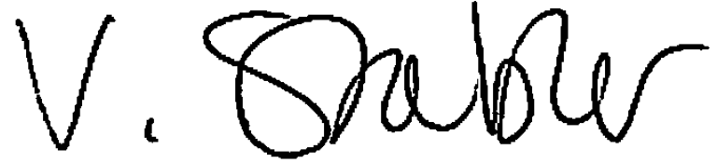
Miss V Stabler
Assistant Principal

Please return to Mrs Allan, Attendance Officer

Pupil Name: ...................................................................................................Tutor Group: .........................

Date of first day of absence………..………... AM or PM Date of return to school………………. AM or PM

Number of school days that your child will be absent from school ……………………………………………..

Please detail the exceptional circumstance for which you are requesting leave of absence

I understand that if the absence request is unauthorised the Local Authority may be notified of the holiday taken and a Penalty Notice may be issued. I understand that a Penalty is issued to each parent for each child taken out of school and that this is a fine of £60 if paid within 21 days and £120 if paid between 21 and 28 days. I also understand that failure to pay a Penalty Notice will result in prosecution, except in limited circumstances.

Name(s) of Parent/Carer(s) making the application

Dr/Mr/Mrs/Ms Forename: ..............................Surname: …………….............. Parental Responsibility Y / N

Dr/Mr/Mrs/Ms Forename: ..............................Surname: ………….….............. Parental Responsibility Y / N

Signed: ...................................................................................................................... Dated: ......................
(Please ensure you are giving at least 7 days’ notice of the proposed absence, retrospective applications cannot be authorised)

For school to complete: AUTHORISED UNAUTHORISED a) b) c) d) (refers to categories below)

