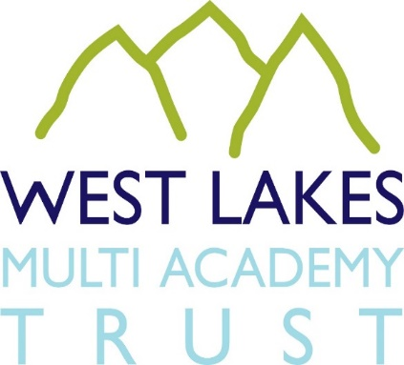

JOB APPLICANT PRIVACY NOTICE

Data controller: West Lakes Multi Academy Trust, Main Street, Egremont, Cumbria
CA22 2DQ

As part of any recruitment process, West Lakes Multi Academy Trust (The Trust) collects and processes personal data relating to job applicants. The Trust is committed to being transparent about how it collects and uses that data and to meeting its data protection obligations.

What information does West Lakes Multi Academy Trust collect?

The Trust collects a range of information about you. This includes:

- your name, address and contact details, including personal email address and telephone numbers;
- details of your qualifications, skills, experience and employment history;
- information about your current level of remuneration, including benefit entitlements;
- whether or not you have a disability for which the Trust needs to make reasonable adjustments during the recruitment process; and
- information about your entitlement to work in the UK.

How does The Trust collect this information?

We may collect this information in a variety of ways. For example, data might be contained in application forms, CVs or resumes, obtained from your passport or other identity documents or collected through interviews or other forms of assessment, including online tests.

The Trust may also collect personal data about you from third parties, such as references supplied by former employers, information from employment background check providers and information from criminal records checks. References will be sought prior to any offer of employment.

How does The Trust store this information?

Data will be stored in a range of difference places, including on your application record, in HR management systems and on other IT systems (including email).

Why does The Trust process personal data?

The Trust needs to process data to take steps at your request prior to entering into a contract with you. It may also need to process your data to enter into a contract with you.

In some cases, The Trust needs to process data to ensure that it is complying with its legal obligations. For example, it is required to check a successful applicant’s eligibility to work in the UK before employment starts.

The Trust has a legitimate interest in processing personal data during the recruitment process and for keeping records of the process. Processing data from job applicants allows The Trust to manage the recruitment process, assess and confirm a candidate’s suitability for employment and decide to whom to offer the job. The Trust may also need to process data from job applicants to respond to and defend against any legal claims.

The Trust may process special categories of data, such as information about ethnic origin, sexual orientation or religion or belief to monitor recruitment statistics. We may also collect information about whether or not applicants are disabled to make reasonable adjustments for candidates who have a disability. The Trust processes such information to carry out its obligations and exercise specific rights in relation to employment.

The Trust is obliged to seek information about criminal convictions and offences for positions within The Trust. Where The Trust seeks this information, it does so because it is necessary for us to carry out our obligations and exercise specific rights in relation to employment.

The Trust will not use your data for any other purpose other than the recruitment exercise for which you have applied.

Who has access to the data?

Your information may be shared internally for the purposes of the recruitment exercise. This includes members of The Trust’s Executive Team, HR team, interviewers involved in the recruitment process, managers in the team with a vacancy, and IT staff, if access to the data is necessary in the performance of their roles.

We will not share your data with third parties, unless your application for employment is successful and we make you an offer of employment. The Trust will then share your data with former employers to obtain references for you (if not sought prior to interview). It may also share your data with employment background check providers to obtain necessary background checks and the Disclosure and Barring Service to obtain necessary criminal records checks.

How does The Trust protect your data?

We take the security of your data seriously. The Trust has internal policies and controls in place to ensure that your data is not lost, accidentally destroyed, misused or disclosed, and it is not accessed except by our employees in the proper performance of their duties. Restricted access to folders, password protection and server security protects data in digital format; paper records are secured in locked filing cabinets in locked buildings to which access is limited to members of the HR team.

How long does The Trust keep data?

If your application for employment is unsuccessful, the Trust will hold your data on file for six months after the end of the relevant recruitment process. At the end of that period, or if you withdraw your consent for the organisation to hold your data during this time, your data will be deleted or destroyed.

If your application for employment is successful, personal data gathered during the recruitment process will be transferred to your HR file (electronic and paper based) and retained during your employment. The periods for which you data will be held will be provided to you in a new privacy notice.

Your rights

As a data subject, you have a number of rights. You can:

- access and obtain a copy of your data on request;
- require the Trust to change incorrect or incomplete data;
- require the Trust to delete or stop processing your data, for example where the data is no longer necessary for the purposes of processing; and
- object to the processing of your data where the Trust is relying on its legitimate interests as the legal ground for processing.

If you would like to exercise any of these rights please contact Karen Wond, HR Officer.

If you believe that the Trust has not complied with your data protection rights, you can complain to the Information Commissioner’s Office. You can contact the ICO at Wycliffe House, Water Lane, Wilmslow, Cheshire SK9 5AF, Tel: 0303 123 1113.

What if you do not provide personal data?

You are under no statutory or contractual obligation to provide data to The Trust during the recruitment process. However, if you do not provide the information, we may not be able to process your application properly or at all.

Automated decision making

Recruitment processes are not based on automated decision making.

Changes to the privacy notice

We reserve the right to update this privacy notice at any time and we will provide you with a new privacy notice when we make any substantial updates. We may also notify you in other ways from time to time about the processing of your personal information.

